# CNCCookbook 2015 CAM Strengths and Weaknesses

# Introduction



Picking the wrong CAM package can be a nightmare…

What sorts of things would you like to know before purchasing CAM Software?  CAM is often expensive, you’ll invest hours learning to use it properly, and it may make the difference between success or failure of your CNC project.  Odds are, the more you know about the various CAM packages you’re considering, the better off you’ll be.

This article presents a different kind of analysis of CAM packages because it’s based not on our view of the packages, but on the views of real users of the software as determined by our [2015 CAM Market Share and Usability Survey](http://blog.cnccookbook.com/2015/12/15/think-know-cam-packages-popular-time-find/). The ratings and information here are drawn entirely from those survey responses.  Moreover, when we ran the survey, the questions were open-ended.  We didn’t pick categories, we simply asked folks to tell us the 3 things they liked most about their CAM software and the 3 biggest frustrations they were having with it.  The results give an unprecedented view into how real users react to the various packages.

CNCCookbook surveys its readers annually about their CAD and CAM preferences. We receive over 3 million visits a year to www.cnccookbook.com. Our audience is about 70% professionals and 30% hobbyist/makers. Geographically, our readership is as follows:

* Americas: 54.14%
* Europe: 23.85%
* Asia: 15.88%
* Rest of World: 6.13%

This report was compiled from hundreds of responses to our CAM Survey that was done in December, 2015.

# Top 16 CAM Package Strengths and Weaknesses

Despite there having been more than 16 packages surveyed, we decided to only cover the Top 16 in order to ensure there were enough responses for each package to allow meaningful analysis. We cover the packages by market segment just as in the other analyses. We’ve rated each package in this report on:

* Likelihood of Adoption: Percentage of trials that wound up adopting.
* Customer Satisfaction: Our score based on how adopters rated the package and whether they were shopping for a replacement.
* CAD Integration & Features: Pct of customers calling out CAD integration or built in CAD features as something they really like about the package, or as something that frustrates them.
* Ease of Use: Customer comments relating to Ease of Use, Support, Documentation, Help, and the like.
* Toolpaths: Customer comments relating to quality of toolpaths, level of control, power, MRR’s, and the like.
* Feature Recognition & Templates: Customer comments relating to a grab bag of features that reduce the work needed to set up a toolpath. Feature recognition and templates or styles are the most common.
* Simulation: Comments relating to built-in simulators.
* Value: Comments relating to price or value at the price.
* 4/5 Axis: Comments relating to multi-axis support
* Posts / Setup: Comments relating to posts and setup.

We binned responses into these categories to make it easier to compare the reaction across packages.

# Feature Popularity

The most likely areas of positive comment were, in order of popularity:

* 4.17 Ease of Use
* 3.14 Toolpaths
* 2.79 CAD Integration / Features
* 2.08 Feature Recognition / Templates
* 1.63 Simulation
* 0.58 4/5 Axis
* 0.56 Value

The numerical index gives an idea of relative popularity. Ease of Use was mentioned nearly 8x more often than Value, for example. Or, looked at another way, Ease of Use trumps quality of toolpaths for many in this audience.

# Biggest Headaches

What goes wrong with CAM Software?

The areas most likely to receive negative comment were, in order of popularity:

* 3.19 Ease of Use
* 1.99 Post / Setup
* 1.95 CAD Integration / Features
* 1.87 Toolpaths
* 1.60 Bugs
* 1.05 Feeds & Speeds
* 0.85 Import / Export
* 0.56 Tool Library
* 0.41 Feature Recognition / Templates
* 0.34 Value
* 0.20 4/5 Axis

One can conclude that the biggest problem the CAM area as a whole faces, is Ease of Use, followed pretty closely by Post / Setup problems, which are something of a specific area for Ease of Use. It’s disappointing to see Bugs scoring so high, but one of the reasons people buy our G-Wizard Editor is to simulate the CAM generated GCode so they can get a second opinion on whether there are bugs.

Looking at these two categories together, it seems that many just want a CAM package that’s easy to use (and Setup / get the Post working), has decent Toolpaths, and decent integration with their CAD package. It doesn’t seem too much to ask for, yet the fact these things are coming up in the survey indicates they are not as common as CNC’ers would like. Having all that goes a long way!

I was also interested to see how high Feeds & Speeds rated on the list of Biggest Headaches.  Again, this was unaided.  Nowhere in the survey were users asked about Feeds and Speeds.  But a great many wrote it in as a problem for the package.  Feeds and Speeds are hard to do and most every CAM package does a pretty lousy job with them.  Toolpaths and the ability to achieve good Material Removal Rates are really hampered by poor Feeds and Speeds, hence it ranks nearly as high.  Do yourself a favor and augment your CAM package with a product like [G-Wizard Calculator](http://www.cnccookbook.com/CCGWizard.html) that can really do Feeds and Speeds well.

# High End Segment Strengths and Weaknesses

Readers who read the initial analysis of the CAM Survey will recall that we divided the packages into 3 segments:

* High-End: More expensive packages with more functionality.
* Tiered: Modular packages available in a range of configurations that span from the Low-End to the High-End.
* Low-End: These are inexpensive packages most commonly used by Hobbyists, but as we’ll see, they’re starting to come up-market to the Professional World.

Here are the overall winners in each feature category for the High End Segment:

* Best CAD Integration & Features: HSMWorks
* Best Ease of Use: OneCNC
* Best Toolpaths: Edgecam
* Best Feature Recognition & Templates: Camworks
* Best Simulation: Edgecam
* Best Value: HSMWorks
* Best 4/5 Axis: Mastercam
* Easiest to Setup / Best Posts: Edgecam
* Pct Positives: Edgecam
* Highest Customer Satisfaction: Edgecam
* Most Likely to Adopt if Tried: OneCNC

Clearly Edgecam, HSMWorks, OneCNC, and Mastercam get the high marks from their users in this market segment.

Individual package analysis follows.

## Camworks



55% of those who tried it adopted Camworks. Their Customer Satisfaction Score was 1.17.

**Summary: Great Feature Recognition and Toolpaths. Post & Setup are pain points along with CAD Integration / Features and Feeds & Speeds.**

**Strengths**

* 133%: Feature Recognition / Templates
* 33%: Toolpaths
* 17%: CAD Integration & Features
* 17%: Ease of Use
* 17%: Simulation
* 217%: Total Positive Feedback

**Weaknesses**

* 50%: Post / Setup
* 33%: CAD Integration / Features
* 33%: Feeds & Speeds
* 17%: Feature Recognition / Templates
* 133%: Total Negative Feedback

## Delcam

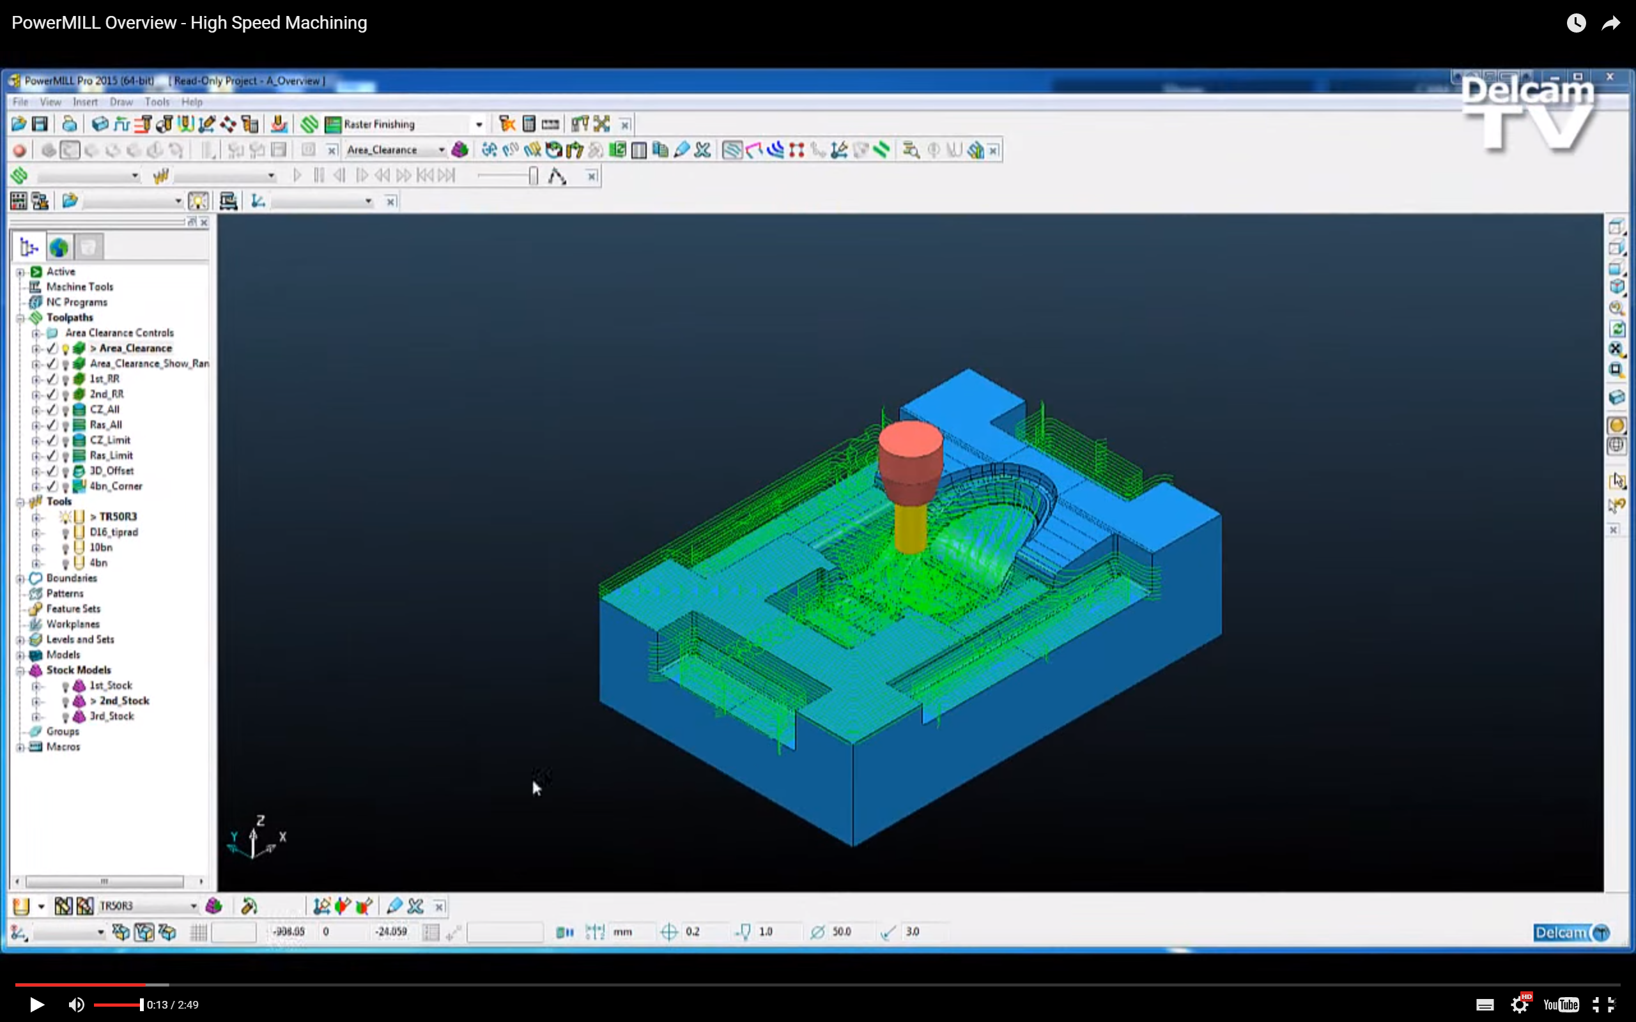

32% of those who tried it adopted Delcam. Their Customer Satisfaction Score was 0.63.

**Summary: Decent Toolpaths, Ease of Use and Templates. Pain points include Posts/Setup, CAD Integration/Features, Bugs, Feature Recognition/Templates, and Tool Library**

**Strengths**

* 13%: Ease of Use
* 25%: Toolpaths
* 25%: Feature Recognition / Templates
* 63%: Total Positive Feedback

**Weaknesses**

* 25%: Post / Setup
* 25%: CAD Integration / Features
* 13%: Bugs
* 13%: Feature Recognition / Templates
* 13%: Tool Library
* 88%: Total Negative Feedback

## Edgecam

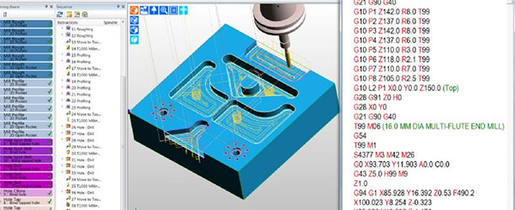

30% of those who tried it adopted Edgecam. Their customer satisfaction score was 1.50—highest in this segment.

**Summary: Great Toolpaths and CAD Integration as well as Simulation are Edgecam’s biggest strengths. In addition Customers like the Feature Recognition / Templates and find Posts and Setup are easier than most CAM. Weaknesses indicate not everyone agrees the CAD Integration and Ease of Use are as good as they could be and Feeds & Speeds need help. With so many areas well regarded and so few negatives, it isn’t hard to see why Edgecam does so well on Customer Satisfaction.**

**Strengths:**

* 83%: Toolpaths
* 50%: CAD Integration / Features
* 33%: Ease of Use
* 33%: Simulation
* 17%: Feature Recognition / Templates
* 17%: Posts / Setup
* 233%: Total Positive Feedback

**Weaknesses:**

* 33%: Ease of Use
* 33%: CAD Integration / Features
* 17%: Feeds & Speeds
* 83%: Total Negative Feedback

## HSMWorks (non Fusion 360)



60% of those who tried it adopted HSMWorks. Customer Satisfaction Score was 1.19.

**Summary: Customers report Best-in-class CAD Integration, excellent Ease of Use, and a broad mix of other positives such as Toolpaths, Simulation, Value, and Feature Recognition / Templates. Weaknesses are in the areas of Feeds and Speeds, some UI, Tool Library, 4/5 Axis Work, Post / Setup, as well as some instability.**

**Strengths:**

* 69%: CAD Integration / Features (Highest score in this category)
* 42%: Ease of Use
* 15%: Toolpaths
* 15%: Simulation
* 12%: Value
* 8%: Feature Recognition / Templates
* 4%: 4/5 Axis
* 165%: Total Positive Feedback

Weaknesses:

* 15%: Feeds and Speeds
* 12%: Ease of Use
* 12%: Tool Library
* 12%: 4/5 Axis
* 8%: Post / Setup
* 4%: Bugs
* 62%: Total Negative Feedback

## Mastercam



50% of those who tried Mastercam adopted it. Customer Satisfaction Score was 0.98.

**Summary: Mastercam users report the Toolpaths are its strongest suite while 4/5 axis support, and Simulation also get kudos. Weaknesses include Ease of Use, Post/Setup, Stability, Feature Recognition / Templates, Tool Library, CAD Integration / Features, and Import / Export. A number of users also mentioned Mastercam is the Industry Standard and it certainly was the most popular in our survey.**

**Strengths**

* 51%: Toolpaths
* 22%: Ease of Use
* 17%: 4 / 5 Axis
* 5%: Simulation
* 5%: Post / Setup
* 100%: Total Positive Feedback

**Weaknesses**

* 32%: Ease of Use
* 29%: Post / Setup
* 24%: Bugs
* 12%: Feature Recognition / Templates
* 12%: Tool Library
* 7%: CAD Integration / Features
* 7%: Feeds & Speeds
* 2%: Toolpaths
* 2%: Import / Export
* 144%: Total Negative Feedback

## OneCNC



Everyone who evaluated OneCNC wound up buying it, which is extremely rare. Customer Satisfaction Score was 0.89.

**Summary: OneCNC customers strongly praise its Ease of Use and also like its Toolpaths and 4/5 Axis Support. Weaknesses are slight with just a few reports of Post / Setup and Stability.**

**Strengths**

* 56%: Ease of Use
* 11%: Toolpaths
* 11%: 4 / 5 Axis
* 78%: Total Positive Feedback

**Weaknesses**

* 11% Post / Setup
* 11% Bugs

# Tiered Segment Strengths and Weaknesses

## Overall

* Best CAD Integration & Features: BobCAD
* Best Ease of Use: Visual Mill
* Best Toolpaths: Aspire
* Best Feature Recognition & Templates: Vectric
* Best Simulation: Visual Mill
* Best Value: BobCAD
* Best 4/5 Axis: SprutCAM
* Easiest to Setup / Best Posts: SprutCAM / Aspire (tied)
* Pct Positives: Visual Mill
* Highest Customer Satisfaction: Aspire
* Most Likely to Adopt if Tried: SprutCAM

Individual package analysis follows.

## Aspire

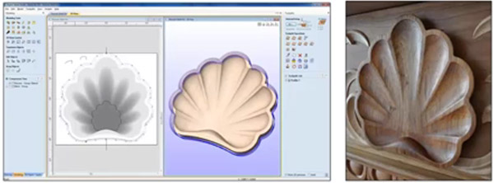

43% of those who evaluated Aspire wound up buying it. Customer Satisfaction Score was 1.40—the best in this class.

**Summary: Biggest strengths would be Toolpaths. Weaknesses are CAD Integration / Features, Ease of Use, Stability, and Feeds and Speeds. But these weaknesses are not felt strongly as Aspire has the highest customer satisfaction in its class.**

**Strengths**

* 20%: Toolpaths
* 10%: CAD Integration / Features
* 10%: Post / Setup
* 40%: Total Positive Feedback

**Weaknesses**

* 20%: CAD Integration / Features
* 10%: Ease of Use
* 10%: Post / Setup
* 10%: Bugs
* 10%: Toolpaths
* 10%: Feeds & Speeds
* 70%: Total Negative Feedback

## BobCAD



30% of those who evaluate BobCAD buy it. Customer Satisfaction Score is 1.10.

**Summary: BobCAD’s biggest strength is CAD Integration / Features. Other strengths include Feature Recognition / Templates and Simulation. Areas of Weakness are Ease of Use, Stability, Post / Setup, Value, and Feeds & Speeds.**

**Strengths**

* 24%: CAD Integration / Features
* 24%: Ease of Use
* 10%: Toolpaths
* 5%: Feature Recognition / Templates
* 5%: Simulation
* 5%: Value
* 71%: Total Positive Feedback

**Weaknesses**

* 43%: Ease of Use
* 29%: Stability
* 19%: Post / Setup
* 19%: Value
* 14%: Toolpaths
* 5%: CAD Integration / Features
* 5%: Feeds & Speeds
* 133%: Total Negative Feedback

## VCarve



58% of people who try VCarve wind up adopting it. Customer Satisfaction Score is 1.00.

**Summary: VCarve’s biggest strength is Ease of Use closely followed by its ability to convert Bitmaps to GCode. Its weakness is the Toolpaths are perhaps not the strongest, but they seem adequate for VCarve’s user base.**

**Strengths**

* 43% Ease of Use
* 14% CAD Integration / Features (Bitmap to GCode)
* 7% Toolpaths
* 7% Simulation
* 71% Total Positive Feedback

**Weaknesses**

* 21%: Toolpaths
* 14%: CAD Integration / Features
* 36%: Total Negative Feedback

## Vectric

Note: This category is an amalgam of customers who own multiple Vectric products.

50% of those evaluating Vectric adopted it with a Customer Satisfaction Score of 0.89

**Summary: Vectric customers like its CAD Integration / Features and Feature Recognition / Templates. Challenges include Ease of Use, Toolpaths, and Feeds & Speeds.**

**Strengths**

* 11% CAD Integration / Features
* 11% Feature Recognition / Templates
* 22% Total Positive Feedback

**Weaknesses**

* 22% Ease of Use
* 11% Toolpaths
* 11% Feeds & Speeds
* 44% Total Negative Feedback

## Cut2D

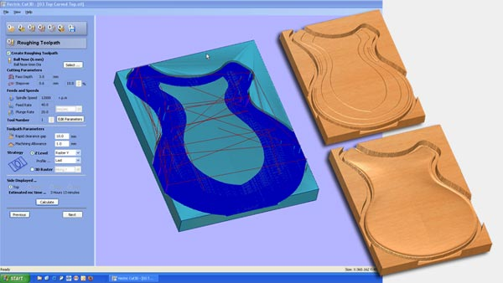

33% of those who try Cut2D wind up purchasing. Customer Satisfaction Score is 0.88.

**Summary: The Cut2D audience didn’t mention features in any of the standard categories as favorites. Challenges were in the areas of Import / Export, Ease of Use, Stability, and CAD Integration.**

**Strengths**

* None mentioned

**Weaknesses**

* 38% Import / Export
* 25% Ease of Use
* 13% Bugs
* 13% CAD Integration / Features
* 88% Total Negative Feedback

## SprutCam



81% of those that tried SprutCam adopted it (Best in Class). Customer Satisfaction Score was 0.76.

**Summary: Customers like SprutCam’s 4/5 Axis Support, Toolpaths, and Feature Recognition / Templates. They’re challenged by Ease of Use, Stability, CAD Integration / features, Import / Export, and Tool Library.**

**Strengths**

* 19% 4/5 Axis Support
* 14% Toolpaths
* 10% Feature Recognition / Templates
* 10% Post / Setup
* 52% Total Positive Responses

**Weaknesses**

* 81% Ease of Use
* 24% Bugs
* 10% CAD Integration / Features
* 10% Import / Export
* 5% Post / Setup
* 5% Tool Library
* 133% Total Negative Feedback

## Visual Mill



28% of those who try Visual Mill adopt it. Customer Satisfaction Score is 0.43.

**Summary: Visual Mill offers Best in Class Ease of Use and a good Simulator. Challenges include Toolpaths (more variety and more efficient toolpaths needed), Stability, Post / Setup, and CAD Integration / Features.**

**Strengths**

* 86% Ease of Use (Best in Class)
* 14% Simulation
* 100% Total Positive Feedback

**Weaknesses**

* 86% Toolpaths
* 29% Ease of Use
* 29% Bugs
* 14% Post / Setup
* 14% CAD Integration / Features
* 171% Total Negative Feedback

# Low End Segment Strengths and Weaknesses

## Overall

* Best CAD Integration & Features: HSMWorks (Fusion 360)
* Best Ease of Use: MeshCAM
* Best Toolpaths: CamBam
* Best Feature Recognition & Templates: - none -
* Best Simulation: MeshCAM
* Best Value: CamBam
* Best 4/5 Axis: CamBam
* Easiest to Setup / Best Posts: - none -
* Pct Positives: CamBam
* Highest Customer Satisfaction: HSMWorks (Fusion 360)
* Most Likely to Adopt if Tried: HSMWorks (Fusion 360)

Individual package analysis follows.

## HSMWorks (Fusion 360)

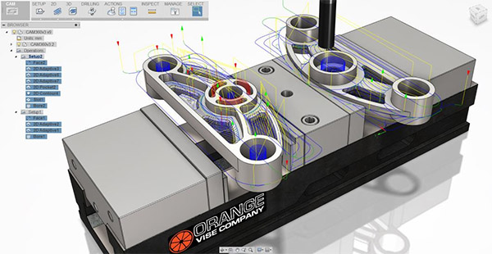

67% of those who tried HSMWorks (Fusion 360) adopted it (Highest in Class). Customer Satisfaction Score is 1.23 (Highest in Class)

**Summary: HSMWorks (Fusion 360) owners report high customer satisfaction, love the CAD Integration / Features, good Ease of Use and Simulator, Good Toolpaths, and a Good Value. Biggest Weaknesses are Post / Setup, Tool Library, with some reporting weakness in Ease of Use, Toolpaths, 4/5 Axis, CAD Integration / Features (mostly sketch/2D CAD), Feeds & Speeds, and Stability.**

**Strengths**

* 43% CAD Integration / Features
* 23% Ease of Use
* 21% Simulation
* 17% Toolpaths
* 13% Value
* 117% Total Positive Feedback

**Weaknesses**

* 15% Post / Setup
* 15% Tool Library
* 13% Ease of Use
* 9% Toolpaths
* 9% 4/5 Axis
* 6% CAD Integration / Features
* 6% Feeds & Speeds
* 4% Bugs
* 85% Total Negative Feedback

## MeshCam



35% of those who tried MeshCam adopted it. Customer Satisfaction Score is 1.00.

**Summary: MeshCam users report Best in Class Ease of Use and Simulator together with Bitmap to GCode capabilities. The only weakness report is a slight issue with CAD Integration / Features.**

**Strengths**:

* 38% Ease of Use (Best in Class)
* 38% Simulation (Best in Class)
* 8% CAD Integration / Features (Bitmap to GCode)
* 85% Total Positive Feedback

**Weaknesses**:

* 8% CAD Integration / Features

## CamBam



38% of those who try CamBam adopt it. Customer Satisfaction Score is 0.87.

**Summary: CamBam users like the CAD Integration / Features, Value, and Simulation. Weaknesses include Import / Export, Post / Setup with some reports of weakness in Toolpaths.**

**Strengths**

* 33% CAD Integration / Features
* 27% Toolpaths
* 27% Value
* 20% Ease of Use
* 7% Simulation
* 113% Total Positive Feedback

**Weaknesses**

* 33% Toolpaths
* 27% Import / Export
* 20% Ease of Use
* 13% Post / Setup
* 7% CAD Integration / Features
* 100% Total Negative Feedback